# Instructions for Installing and Configuring a Single Node MongoDB Database

The MongoDB database is installed and configured for production use onto a cluster of several virtual machines. For exploring the use of this technology on a small scale, however, it is possible to set it up to execute on a single virtual machine which is what these instructions describe. The installation proceeds in two phases: create a virtual machine and then install and start MongoDB.

## Section 1: Instructions for setting up an EC2 instance (virtual machine)

1. Select “Services” on the AWS console. Then select “EC2”



1. Launch a new EC2 instance by clicking on “Launch Instance”



1. Select the Ubuntu 18.04 Amazon Machine Image (AMI)



Select an instance (VM) type of m4.xlarge

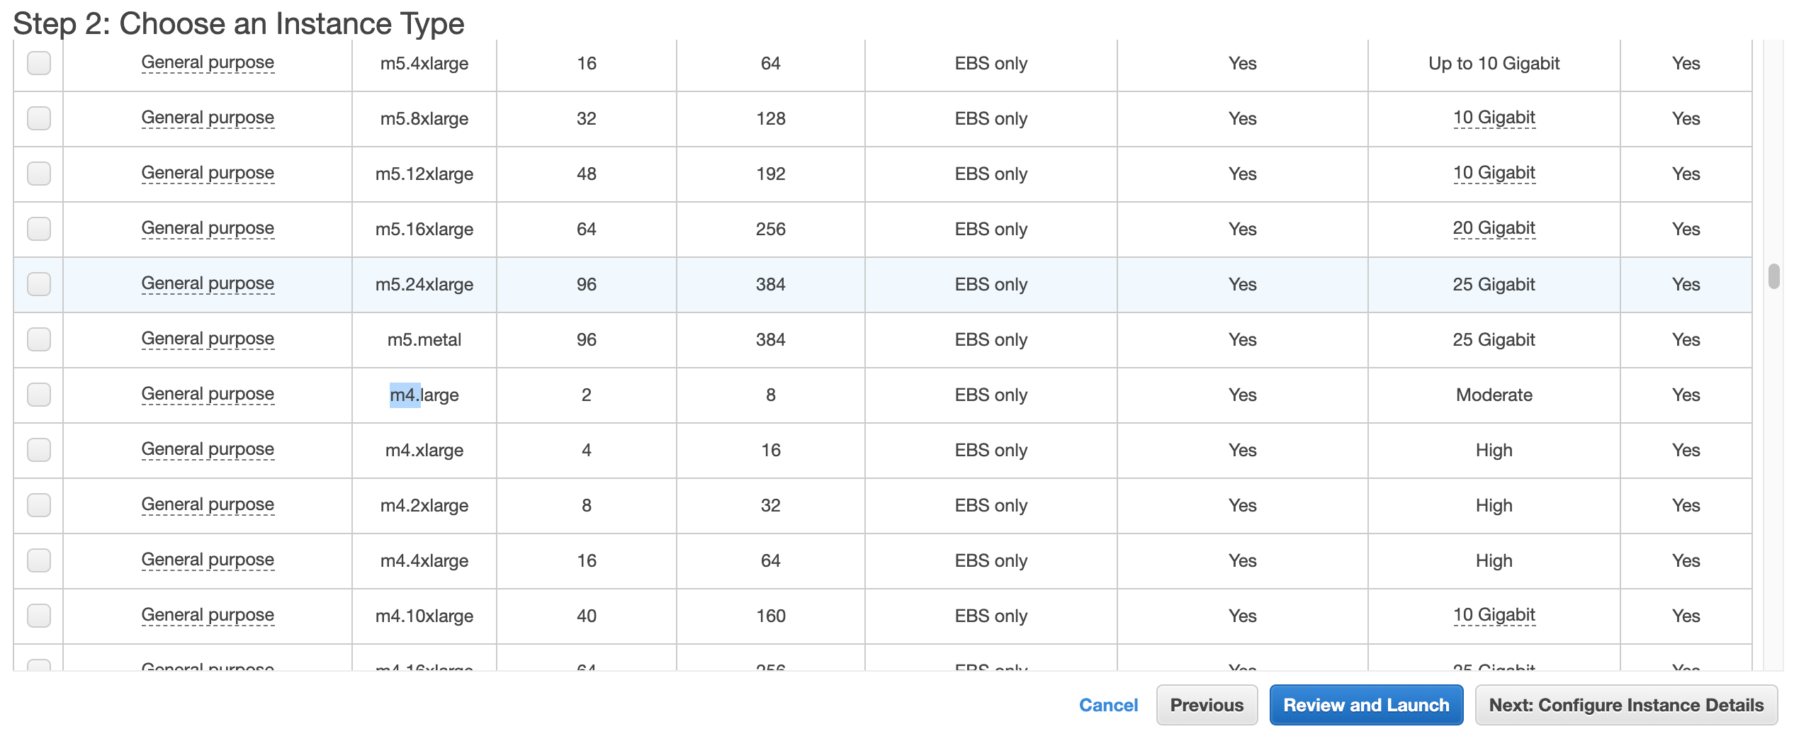

1. Select “Next: Configure Instance Details”



1. Select “Next: Add Storage”



1. Change the root storage size from 8 GiB to 32 GiB. Then select “Review and Launch”



1. Now “Launch” the instance



1. Select an existing key pair (or create a new pair). You can use the same key pair you created for your EMR instances. Make sure to check the “I acknowledge…” checkbox.



1. You should see this. Select “View Instances”



1. Wait until the instance state is “running”. Note that the public address (Public DNS) is provided for use in connecting via ssh or scp to the instance.



1. Now you can ssh to the instance the easy way as follows.
   1. Make sure you check the EC2 instance
   2. Click on the “Connect” button.



c) Select the “SSH Client” tab



d) Cut and paste the example ssh command that appears into your terminal to connect to your instance



Note that in this case the user name of your account is “ubuntu” and the address of your instance <Public DNS (IPv4)> is also used. So the ssh command about is built as follows. Note <Public DNS (IPv4)> is replaced with the actual value listed in the previsouly shown instance information pane.

1. Now you can ssh to the instance as follows.

ssh -i emr-key-pair.pem ubuntu@<Public DNS (IPv4)>

## Section 2: Instructions for installing MongoDB

1. Run the below command to Import the MongoDB repository public key used by the Ubuntu package management system. The operation should respond with an OK:

wget -qO - https://www.mongodb.org/static/pgp/server-4.2.asc | sudo apt-key add -

1. Add the repository of MongoDB to /etc/apt/sources.list.d/ mongodb-org-4.2.list, for example for the latest 4.2 version. Note, the following is all one line:

echo "deb [ arch=amd64 ] https://repo.mongodb.org/apt/ubuntu bionic/mongodb-org/4.2 multiverse" | sudo tee /etc/apt/sources.list.d/mongodb-org-4.2.list

1. Update the repositories:

sudo apt-get update

1. Install MongoDB (this might take a while):

sudo apt-get install -y mongodb-org

1. You can start MongoDB with

sudo service mongod start

1. You can start the MongoDB Shell with the following. Enter this to do the assignment exercises:

mongo

1. In case you want to stop your MongoDB instance form running (not likely for our exercises) you can do so with:

sudo service mongod stop